打印PRINT
- 请使用电脑访问http://www.lib.bnu.edu.cn/content/wen-yin-fu-wu，下载并安装自助打印驱动。
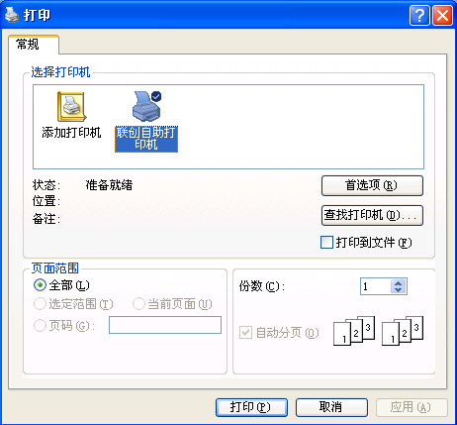
Please visit the following URL on the computer.
http://www.lib.bnu.edu.cn/content/wen-yin-fu-wu
Download and install the Self-service Printer Driver.

- 在电脑端打印文件时，请选择正确的打印机打印文件。如图1所示。
Open your file on the computer, click “Print”, and choose the correct printer. As shown in figure 1.
图1选择正确打印机

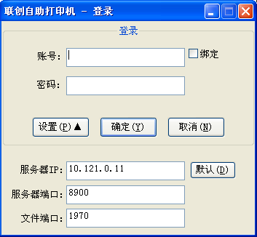
- 点击打印后，如需双面打印，请选择打印机属性，在布局栏选择双面打印；如需彩色打印，请在打印机属性里的纸张/质量栏内选择彩色。输入账号和密码。默认账号是学号，默认密码是一卡通查询密码。（请不要在公共区域电脑上绑定个人账号，例如图书馆、机房、教室等）
如图2所示。
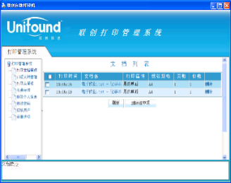
If you need a printing on both sides of a page, please click the “Printer Properties”, and select Two-sided printing in the Page Layout tab. If a color printing needed, click the “Printer Properties”, and select the color option in the Paper/Quality tab. Please enter the name and password. The default name is your Student ID and the default password is the same as your campus card query password.
图2登录界面
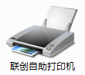
Do not bind your account on the public computers, such as in library, classrooms, etc.
As shown in figure 2.
- 双击桌面图标，可管理个人作业，用户信息等。
如图3所示。
When you want to manage print jobs or view your personal work, double click the icon on the desktop.
图3管理个人文档
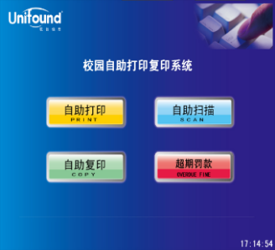
As shown in figure 3.

使用帮助
HELP
- 到任意自助文印一体机，在机柜上点击“自助打印”。如图4所示。
Click “PRINT” on an available Self-service Printer. As shown in figure 4.
- 请使用校园卡在刷卡区域进行刷卡确定。如图5所示。
Swipe your campus card on the designated area. As shown in figure 5.
- 自动显示当前打印队列，再次刷卡确定，文件将打印输出。如图6所示。
图4选择“自助打印”界面
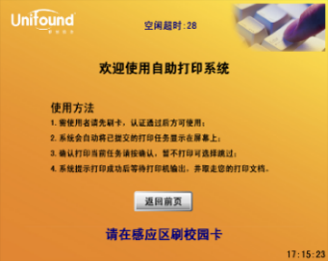
The current print queue will be shown on the screen. Swipe your card again to confirm the print job and your file will be printed. As shown in figure 6.
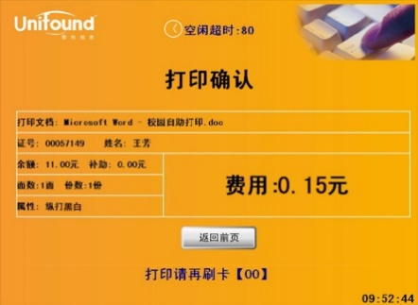
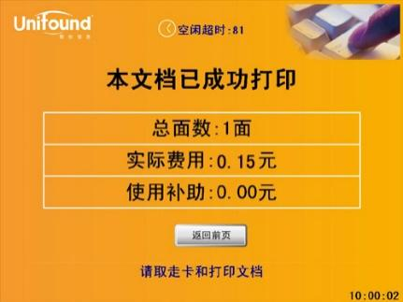

图5提示刷卡界面
图6打印确认和完成界面

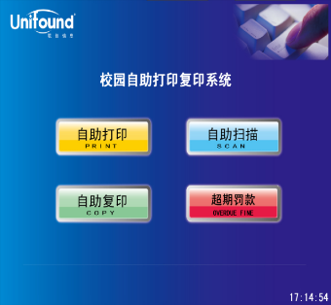
复印 COPY

使用帮助
HELP
- 在任意自助文印一体机，并在操作界面上选择“自助复印”功能选项。

如图7所示。
Click “COPY” on an available Self-service Printer.
As shown in figure 7.
图7选择“自助复印”界面
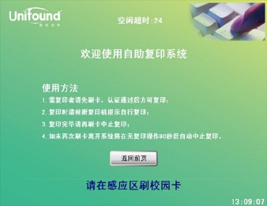
- 弹出提示刷卡界面。请使用校园卡在刷卡区域进行刷卡确定。
如图8所示。
Swipe your campus card on the designated area.
As shown in figure 8.
图8提示刷卡界面
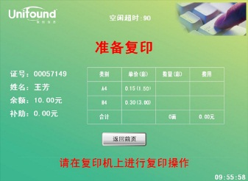
- 刷卡确定后，界面中将显示您的帐户信息、余额等情况。如图9所示。

Your account information such as your name, ID, balance will be presented on the screen. As shown in figure 9.

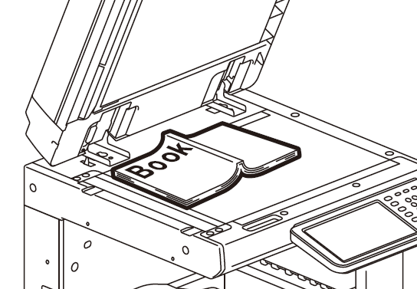
- 将文件放在输稿器上，有字面朝上。或放在玻璃稿台上，字面朝下。如图10所示。
图9刷卡确认后界面

Put the file on the Reversing Automatic Document Feeder (RADF), and let the file face up. Or put it on the Original Glass, and let the file face down.
As shown in figure 10.
图10文件放置
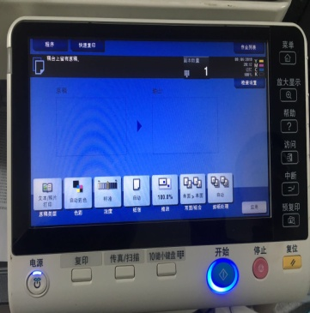
- 认证通过，在复印机上按下复印键，复印界面将变为“就绪”状态。

如图11所示。

Press the copy button, the copy interface will become "READY".
As shown in figure 11.

- 完成全部的复印任务后，请取走复印完成的文档。

Please take all the copied documents up with you before you leave.
图11按下复印键后界面
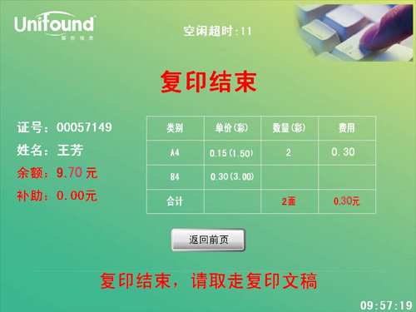
- 再次刷卡将终止本次复印任务，并对您本次的复印任务进行金额结算。如图12所示。
Swipe your card again to finish the job.

The balance of your account will be shown on the screen.
As shown in figure 12.
图12复印完成界面

扫描SCAN

使用帮助
HELP
- 在任意自助文印一体机，并在操作界面上选择“自助扫描”功能选项。

如图13所示。
Click “SCAN” on an available Self-service Printer.
As shown in figure 13.
图13选择“自助扫描”界面
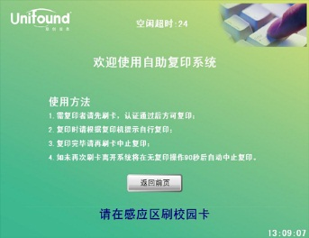
- 弹出提示刷卡界面。请使用校园卡在刷卡区域进行刷卡确定。
如图14所示。
Swipe your campus card on the designated area.
As shown in figure 14.
图14提示刷卡界面

- 将文件放在输稿器上，有字面朝上。或放在玻璃稿台上，字面朝下。如图15所示。
Put the file on the Reversing Automatic Document Feeder (RADF), and let the file face up. Or put it on the Original Glass, and let the file face down.
As shown in figure 15.
图15文件放置
- 在打印机上依次按下“菜单”-“扫描”-“地址簿”-“常用”

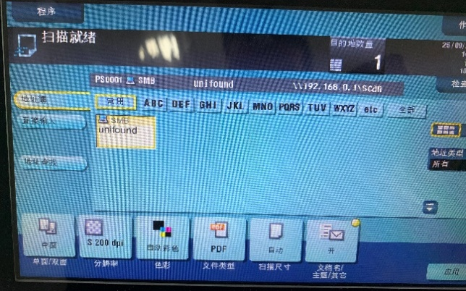
-“SMB-unifound”后按“开始”扫描。如图16所示。

Select "menu" - "scan" - "address book" –

"common" - "SMB - unifound" on the printer screen.

Press "start" to begin the scanning. As shown in figure 16.

- 再次刷卡，完成扫描操作。
Swipe your card again to complete the scan operation.
图16按下开始键后界面

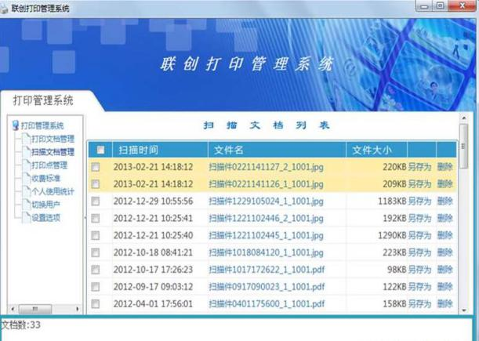
- 在电脑端登录联创自助打印系统，可下载扫描的文件。
图17扫描文档列表
如图17所示。
Login self-service printing system on the computer and download the scanned file.
As shown in figure 17.

手机打印

1．关注图书馆手机公众号，选择“自助打印”，或通过浏览器访问print.lib.bnu.edu.cn，在操作界面上选择“云打印”功能选项。如18所示。

Follow the Wechat account of the library and click “ self-service printing” in it. Or enter the URL: print.lib.bnu.edu.cn, and click “cloud printing” on the interface. As shown in figure 18.
图18选择“自助扫描”界面

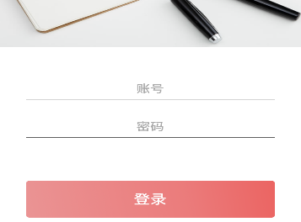
2．在弹出的界面输入账号和密码。默认账号是学号，默认密码是一卡通查询密码。
如19所示。
Enter your name and password in the interface. The default name is your Student ID and the default password is the same as your campus card query password. As shown in figure 19.

3．点击“选择文件”上传需要打印的文件。选择颜色等配置后选择“上传”提交到云端。
图19输入用户名和密码
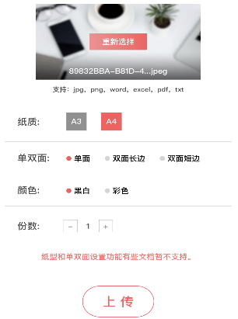
如20所示。备注：苹果用户选择文档类文件前需要保存到手机：打开Word类文件-点击右上角三个点后选择用其它应用打开-选择存储到文件-iCloud云端或者我的iPhone后点击添加。
Click "select file" to upload the file to be printed. After selecting the color and other configuration, select "upload" and submit it to the cloud. As shown in figure 20.Apple users need to save documents to their mobile phone before selecting files: open your MS Word files, click the three points in the upper right corner, open files in other apps, and choose to store them in the file -iCloud or click add on my iPhone.

4．在图书馆可打印的自助一体机上刷卡打印所需文件。
图20上传文件
Print your files on an available self-service in the library.

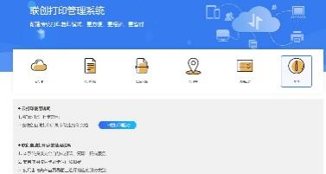
云打印

1．通过浏览器访问print.lib.bnu.edu.cn，在操作界面上选择“云打印”选项，默认账号是学号，默认密码是一卡通查询密码。如图21所示。
Enter the URL: print.lib.bnu.edu.cn, and click “cloud printing” on the interface. The default name is your Student ID and the default password is the same as your campus card query password. As shown in figure 21.

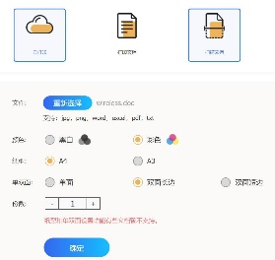
2．登录后选择上传文件，选择颜色、份数等信息后点击确认提交。
如图22所示。
After logging in, select the upload file, select the color, number of copies and other information, and click Confirm to submit. As shown in figure 22.

3．已上传的待打印文档可点击菜单“打印文档“查看。
图22上传文件
如图23所示。
The uploaded document to be printed can be viewed by clicking the menu "Print Document".
As shown in figure 23.
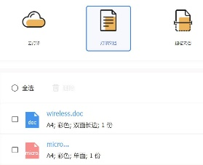

4．在图书馆可打印的自助一体机上刷卡打印所需文件。
图20上传文件
Print your files on an available self-service in the library.
图23打印文档

自助打印、复印、扫描收费标准
纸型 | 页面 | 复印 | 打印 | 扫描
A4 | 黑白单面 | 0.12元/页 | 0.12元/页 | 0.05元/1024kb
 | 黑白双面 | 0.24元/页 | 0.24元/页
 | 彩色单面 | 1.00元/页 | 1.00元/页
 | 彩色双面 | 2.00元/页 | 2.00元/页
Charging for Print/Copy/Scan
Paper | Page | Copy | Print | Scan
A4 | One-side Printing | ￥0.12/ Page | ￥0.12/ Page | ￥0.05 /1024kb
 | Two-sides Printing | ￥0.24/ Page | ￥0.24/ Page
 | One-side Color Printing | ￥1.00/ Page | ￥1.00/ Page
 | Two-sides Color Printing | ￥2.00/ Page | ￥2.00/ Page

